Evaluation of Saliva Procurement and Integrated Testing (SPIT) booklet in Measuring Cortisol and DHEA Levels
Marshall Roll
Introduction
Cortisol and DHEA are adrenal hormones that affect stress levels in the body; measuring diurnal trends in these hormones is a key facet of endocrinologic research. As such, developing effective modes of sample collection is critical to obtaining reliable estimates of hormonal variations. This report seeks to evaluate the efficacy of the Saliva Procurement and Integrated Testing (SPIT) booklet and analyze trends in cortisol and DHEA variation. Data for this project was collected from 31 healthy control subjects four times a day in the following sequence: at wake, 30 minutes after wake, lunchtime (variable by participant), and 600 minutes after wake. This process was repeated for three consecutive days, with the time of measurement being recorded both by an electronic monitoring cap (cap time), which houses the SPIT booklet throughout the day, and manually by participants in the booklet (booklet time). To evaluate efficacy, we analyzed internal consistency of timing (if on average, cap and booklet times were similar) and treatment adherence (the proportion of participants completing measurements on time). We also analyzed whether there is an association between time since wake and cortisol and DHEA levels and whether this association follows the established diurnal trends.
Methods
Waking time was recorded by participants, and both cap and booklet time were calculated using participant-recorded wake time as the baseline. Cortisol levels greater than 80 nmol/L or DHEA levels greater than 5.205 nmol/L were taken as impossibly high values and removed. The distribution of missing values was assessed using exploratory visualizations and tables to determine if there was a clear relationship between missingness and any of the available variables (cap time, booklet time, cortisol, and DHEA).
To assess the internal consistency of timing, a mixed model with random intercepts for participants will be fit to account for repeated measures over the course of the day using minutes from wake measured by the cap as the outcome and minutes from wake measured by the booklet as the predictor. Agreement was determined by the predicted difference between cap and base time at baseline and the spread of subject-specific trajectories (random intercept standard deviation). Repeated measures correlation on complete cases was also calculated to determine the agreement between cap and book time over the entire day studied. Furthermore, cap or book time was selected for use in the remainder of the analysis based on its agreement and levels of missingness.
Adherence to the timing schedule was assessed at two out of the four sampling times, with wake and lunch time excluded. Good adherence was defined by a recording within 7.5 minutes of the appropriate time since wake, while adequate adherence was defined by a recording within 15 minutes. Adherence was calculated using the selected time measure based on the prior analysis.
Diurnal trends of cortisol and DHEA were modeled using piecewise linear regression with the selected measure of time since wake as the predictor and a knot at 30 minutes as established in the literature. This allows predictions to vary before and after the knot point and gives estimates of the effect prior to 30 minutes and the change after 30 minutes. Random intercepts for participants were also included to account for correlation between repeated measures within individuals. To determine the effect of cortisol and DHEA after 30 minutes, the effect prior to 30 minutes and the change were summed. Then, to generate estimates from the model, the coefficients were multiplied by 30, exponentiated, and subtracted from 1 to yield the average predicted percentage change in cortisol and DHEA levels over a 30-minute period. Confidence intervals were calculated on the linearly transformed quantities using the delta method. The alpha threshold to determine significance will be 0.05 across all analyses. All analysis was conducted using R version 4.5.1.
Results
After applying exclusion criteria, 10% of booklet times were missing while 17% of cap times were missing out of the 372 total samples expected. 84% of individuals had complete records on the cap, 91% had complete records in the booklet, and 77% on both (Table 1). There was a slight systematic difference between the two recording methods, with cap readings occurring an average of about 10 minutes later than booklet recordings and slight subject-specific variability (random intercept SD = 6 minutes). Within-subject correlation for complete cases is very high (repeated measures correlation, r = 0.99) (Figure 1). Between 5-30% of observations were incomplete at each of the four time points, with most time points having higher levels of missingness in the cap compared to the book. Given these results, booklet time was preferred for use in subsequent analyses.
Using booklet time, 73% of readings 30 minutes after wake were good (within 7.5 minutes), while 84% of readings were adequate (within 15 minutes). For readings taken 600 minutes after wake, 40% of readings were good and 48% were adequate (Table 1). The first and second readings tended to occur on time, while the lunchtime measurement typically occurred between 240 and 360 minutes after wake and the distribution of the final reading exhibited higher right skew (Figure 2).
The piecewise linear regression model for cortisol predicted an increase in cortisol levels by an average of 13.99% in the first 30 minutes after waking (95% CI: (-10.99%, 45.98%), p = 0.395); this difference is not statistically significant. After 30 minutes, there is a statistically significant predicted decrease in cortisol of 6.10% for every subsequent half hour (95% CI: (-7.27%, -4.92%), p < 0.001) (Table 2, Figure 3). For DHEA levels, there is a statistically significant predicted decrease of 43.60% in the first 30 minutes after waking (95% CI: (-54.20%, -30.55%), p < 0.001). After 30 minutes, there is a statistically significant predicted decrease in DHEA of 4.26% in each subsequent half hour (95% CI: (-5.26%, -3.24%), p < 0.001) (Table 2, Figure 4).
Discussion
The SPIT test for cortisol and DHEA levels matches established trends of diurnal variation of these hormones, with cortisol levels predicted to peak about half an hour after wake and DHEA levels predicted to be highest at wake with both values declining steadily after the first 30 minutes awake. The timekeeping system for the SPIT test is highly internally consistent, with minimal deviations between cap and booklet time. However, cap time is more prone to missing data than booklet time, indicating that improvements could be made to use of the electronic cap. Adherence is strong in the early samples but diminishes over the course of the day; this means that estimates near the end of the day could

Tables and Figures
 | By Sample |  |  |  | Total
Characteristic | 1 N = 93 | 2 N = 93 | 3 N = 93 | 4 N = 93 | N = 372²
Wake to Booklet Time (Minutes)¹ | 0.90 (3.71) | 34.40 (9.55) | 322.85 (84.87) | 641.50 (84.19)
(Missing)² | 5 (6%) | 6 (7%) | 11 (12%) | 13 (14%) | 35 (10%)
Complete Booklet |  |  |  |  | 337 (91%)
Wake to Cap Time (Minutes)¹ | 5.12 (9.20) | 50.11 (34.97) | 323.41 (79.63) | 658.86 (99.07)
(Missing)² | 16 (18%) | 23 (25%) | 12 (13%) | 10 (11%) | 61 (17%)
Complete Cap |  |  |  |  | 311 (84%)
Complete Cap and Booklet |  |  |  |  | 285 (77%)
Cortisol (nmol/L)¹ | 7.38 (6.05) | 9.00 (4.94) | 3.21 (2.29) | 3.20 (4.98)
(Missing)² | 0 (0%) | 1 (2%) | 2 (3%) | 3 (4%) | 6 (2%)
DHEA (nmol/L)¹ | 1.78 (1.27) | 1.11 (0.92) | 0.51 (0.46) | 0.50 (0.65)
(Missing)² | 0 (0%) | 1 (2%) | 2 (3%) | 2 (3%) | 5 (2%)
Good Adherence -Booklet (±7.5 minutes)¹ | - | 68 (73%) | - | 37 (40%)
Adequate Adherence - Booklet (±15 min)¹ | - | 78 (84%) | - | 45 (48%)
¹Mean (SD); n (%)
²n (%)
Table 1: Patient characteristics by sample number (1: wake time, 2: 30 minutes after wake time, 3: lunch time, 4: 600 minutes after wake time); adherence time calculated using booklet time.

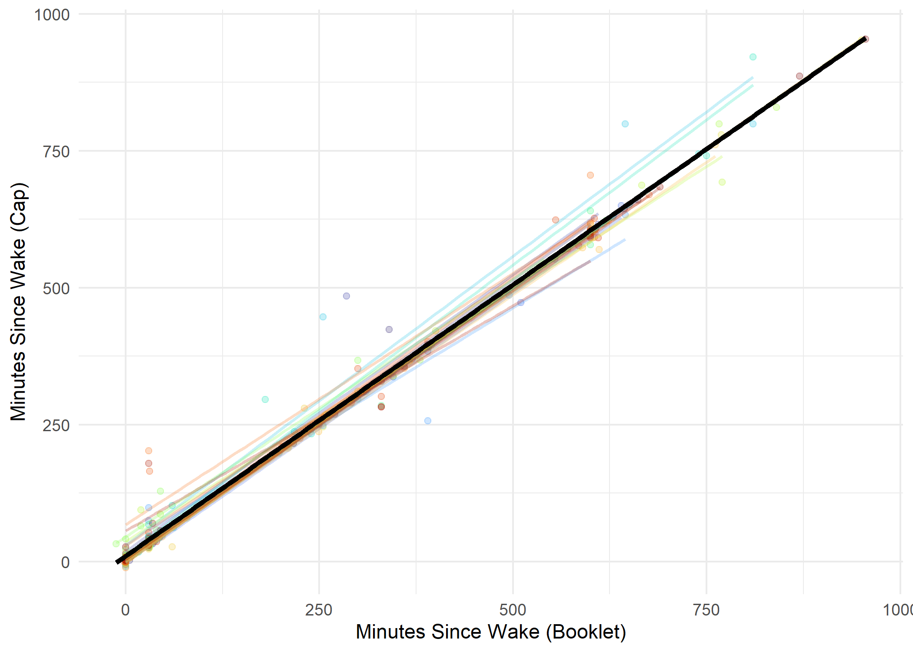
Intercept: 10.2
Slope: 0.99
Correlation (Repeated Measures): 0.99
Figure 1: Black, bold line indicates mixed model fit; colorful, translucent lines indicate subject-specific trajectories. Correlation calculated with complete cases only.

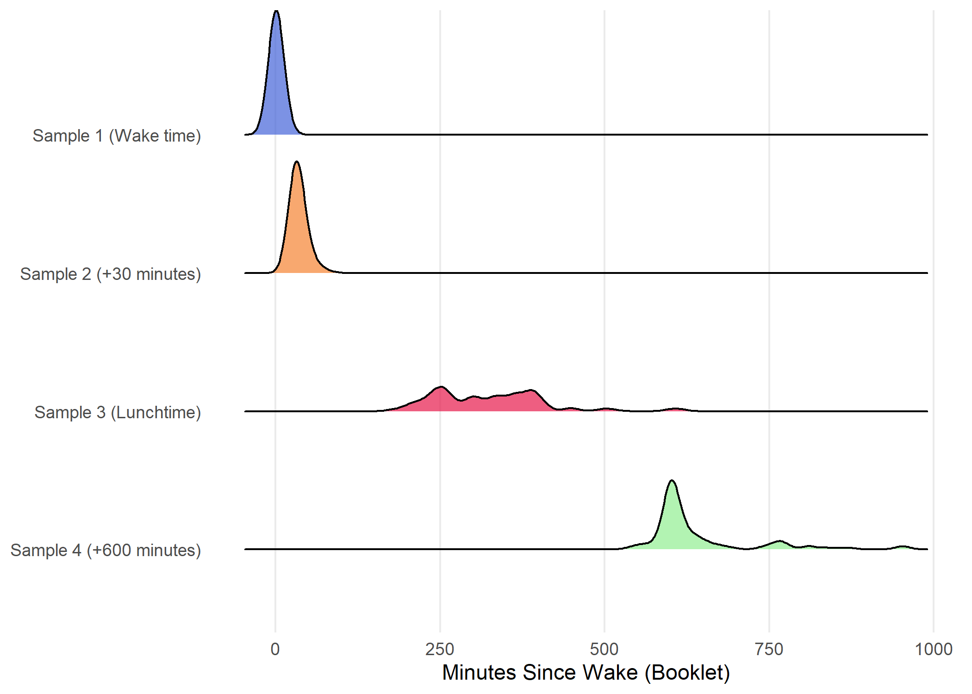
Figure 2: Distribution of minutes since wake as measured by booklet for each of the 4 samples

Outcome | Time Since Wake | Mean Percent Change/ 30 min. | 95% CI |  | p-value
Cortisol | 0-30 minutes | 13.99 | (-10.99, 45.98) |  | 0.395
 | After 30 min | -6.10 | (-7.27, -4.92) |  | <0.001
DHEA | 0-30 minutes | -43.60 | (-54.2, -30.55) | <0.001
 | After 30 min | -4.26 | (-5.26, -3.24) | <0.001
Table 2: Outcomes from piecewise linear models for each of cortisol and DHEA reported as mean predicted percent change in cortisol/DHEA in a 30-minute period

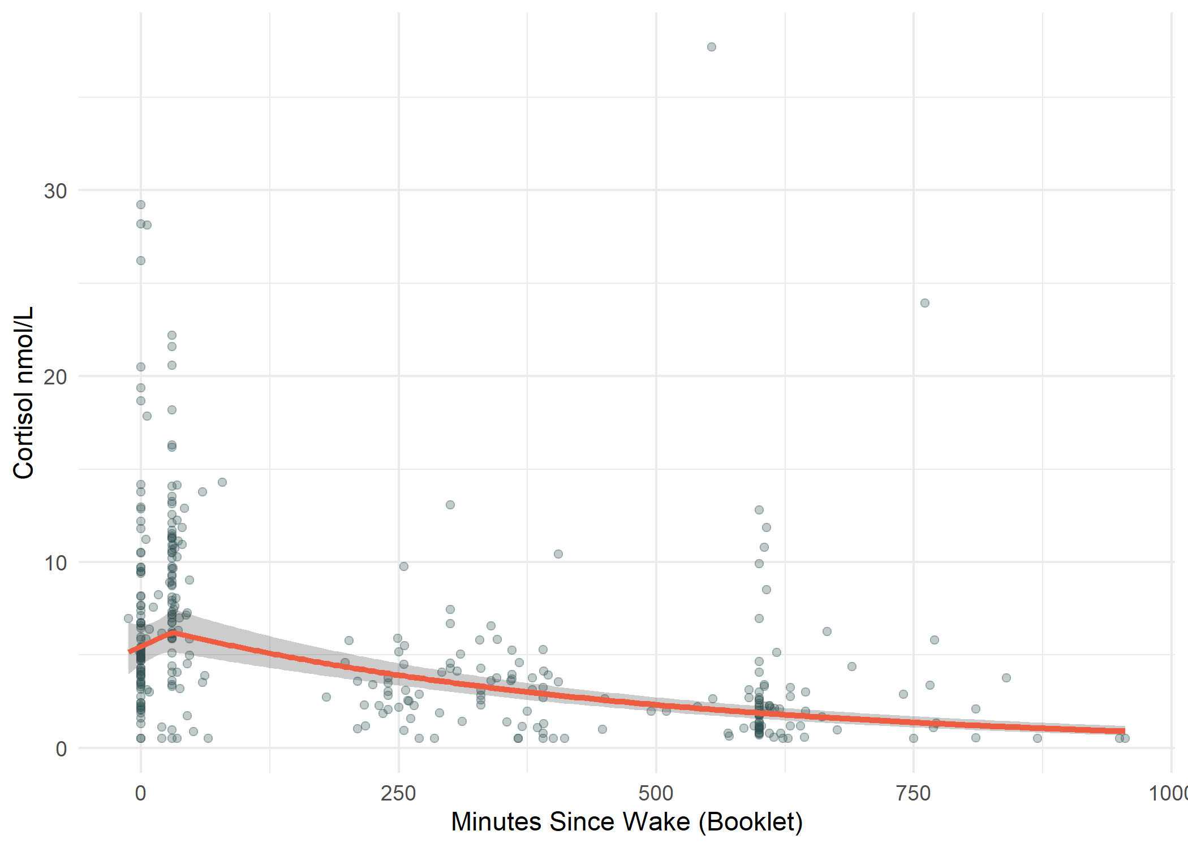
Figure 3: Predicted relationship between time since wake as measured by booklet and cortisol levels; gray band indicates 95% confidence interval for population-average predicted cortisol trajectory, reflecting uncertainty in the estimated mean

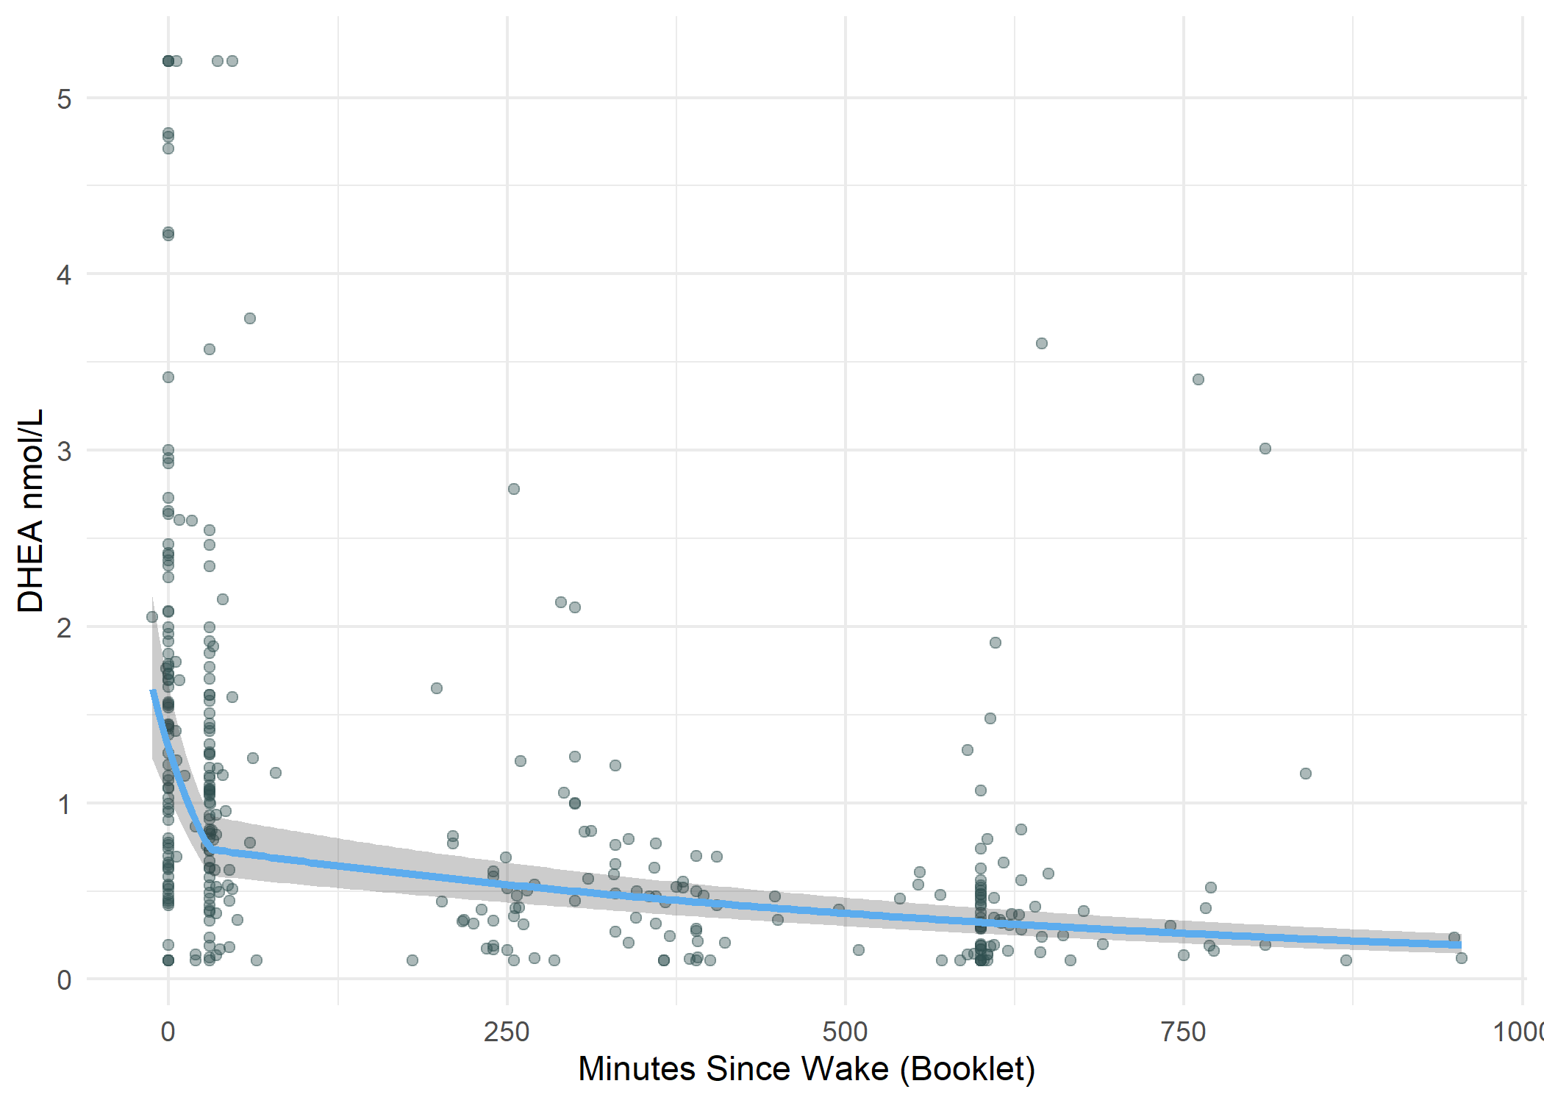
Figure 4: Predicted relationship between time since wake as measured by booklet and DHEA levels; gray band indicates 95% confidence interval for population-average predicted DHEA trajectory, reflecting uncertainty in the estimated mean

